Instantiate Clock IP

1. Find the core:
- Click on IP Catalog in the Project Manager area,
- Type the name of the core you are looking for in the search bar. In our case “clock”
- Click on the Clocking Wizard

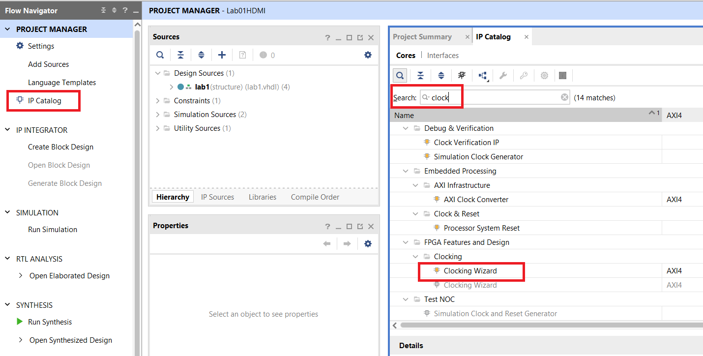

2. Configure the IP core:
- Change the Primary frequency to 50Mhz
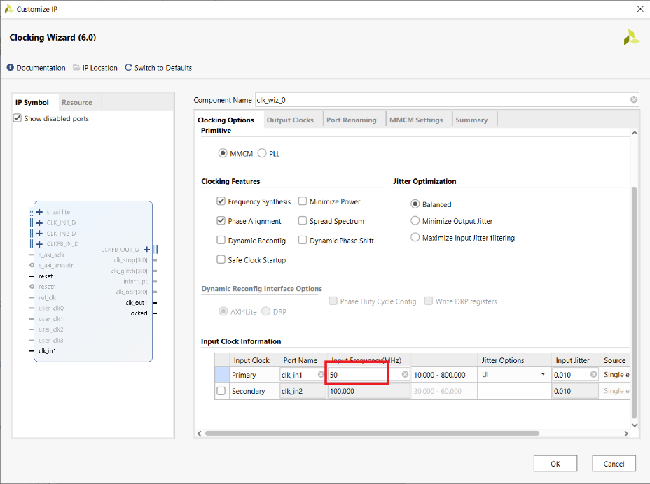

- Set clk_out1 to 74.25Mhz
- Set clk_out2 to 371.25Mhz
- Set reset to active low (off screen at bottom)
- Select locked (off screen at bottom)
- Ignore WARNING text
- Click OK

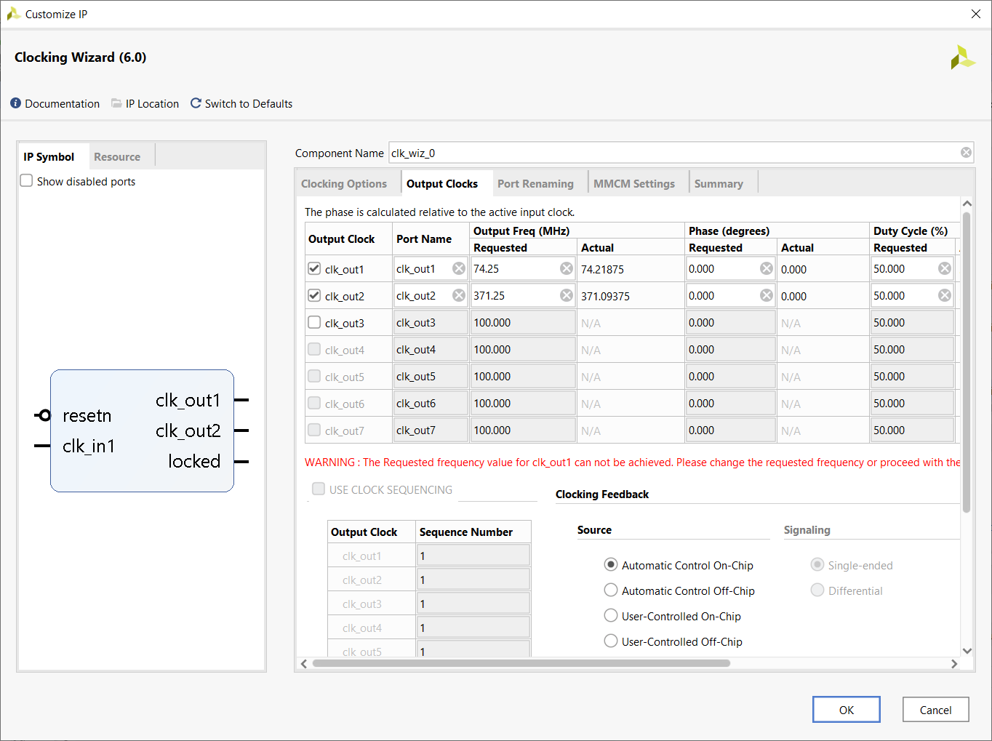

In the Generate Output Products pop-up, click Generate

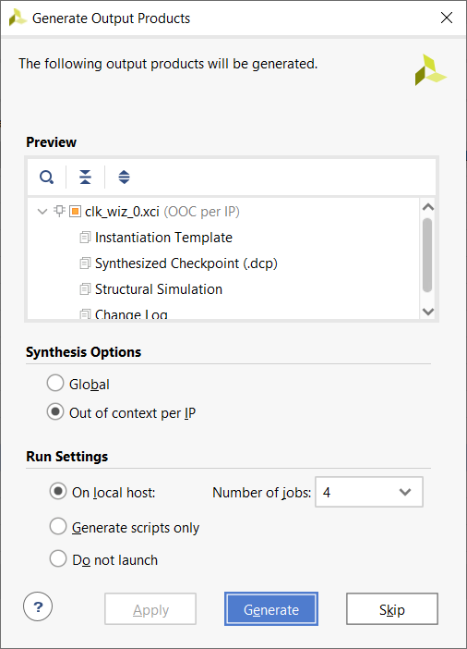

In the Generate Output Products pop-up, click OK
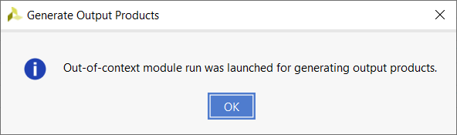

Add the clk_wiz_0 component to your package file as follows:

component clk_wiz_0 is
PORT (
clk_out1 : OUT STD_LOGIC;
clk_out2 : OUT STD_LOGIC;
resetn : IN STD_LOGIC;
locked : OUT STD_LOGIC;
clk_in1 : IN STD_LOGIC);
end component;

Install Custom IP core for HDMI

- Download the provided IP core found at
https://www.realdigital.org/doc/715356000ec89fbfd26a44cd2444659b
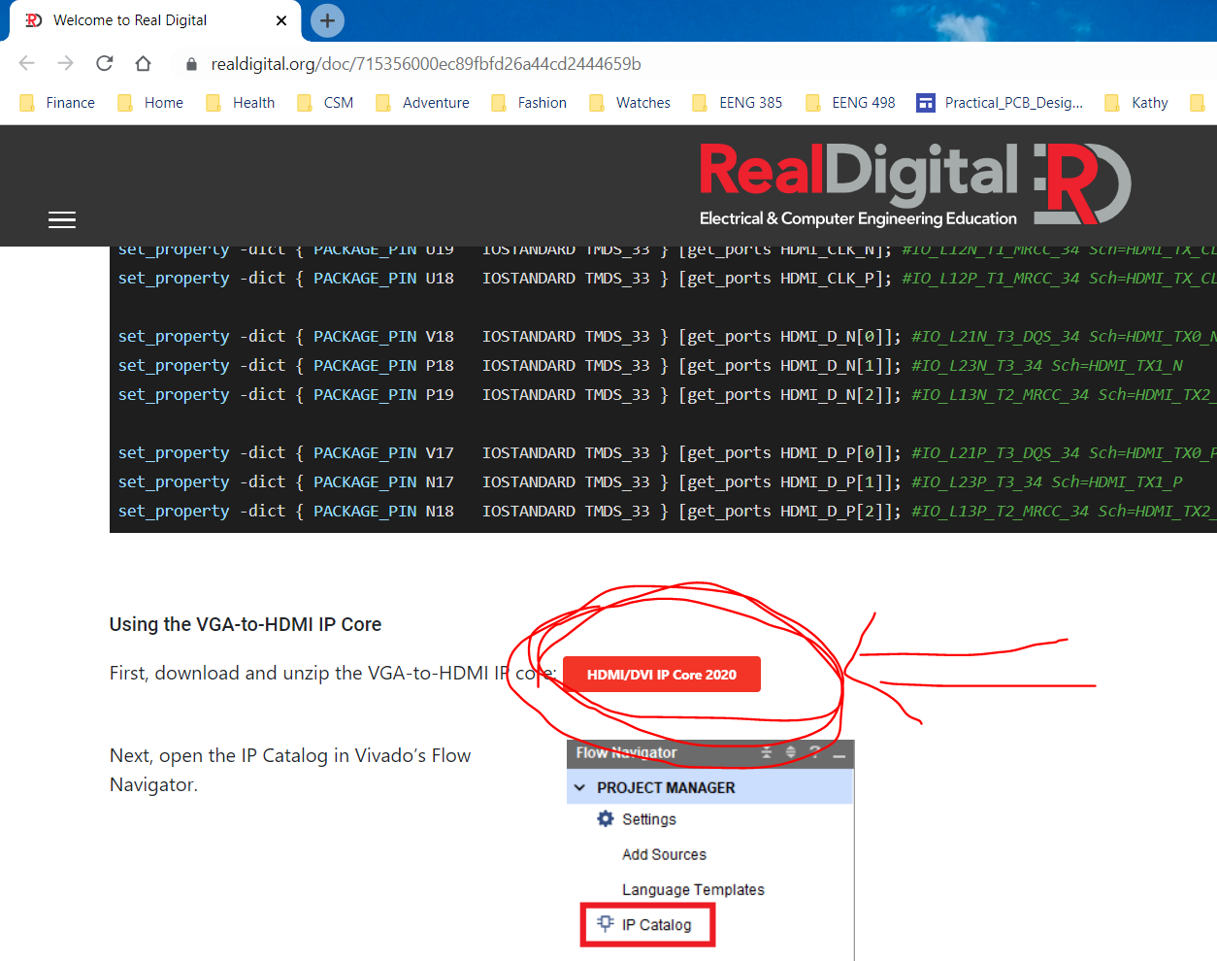

- Unzip the contents of this and place the resulting folder (RD_hdmi_ip2020) in a folder called <course>/LabAssignments/ipRepo You will be building IP later in the course and will store it in this same folder.

- Add the repository:
- Click IP Catalog
- Right mouse click Vivado Repository
- Select Add Repository…

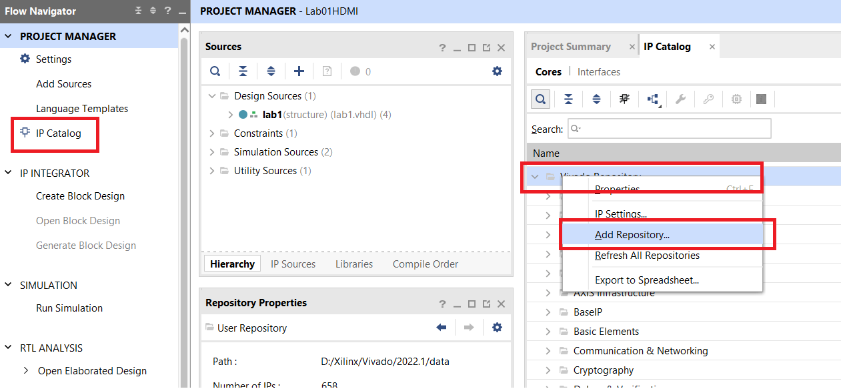

- In the pop-up, navigate to the ipRepo folder, click select. Click OK in the Add Repository pop-up.
- If you’ve added IP to the ipRepo folder after that already having added it, then you will want to select Refresh All Repositories instead of Add Repository…

Instantiate RGB to HDMI Converter

- Double click the HDMI/DVI Encoder from User Repository
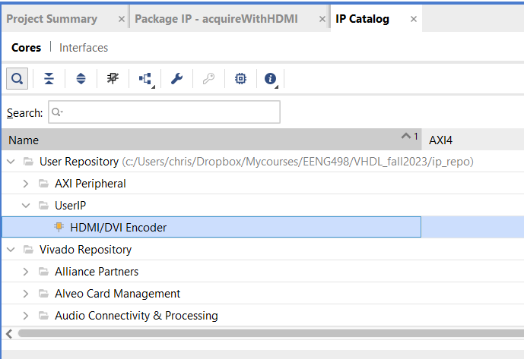

- In the Customize IP pop-up, set the Mode to HDMI. Click OK.
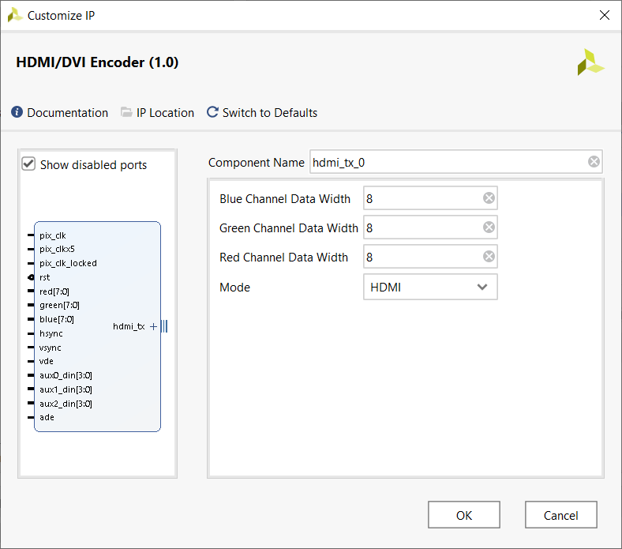

- In the Generate Output Products pop-up, click Generate.

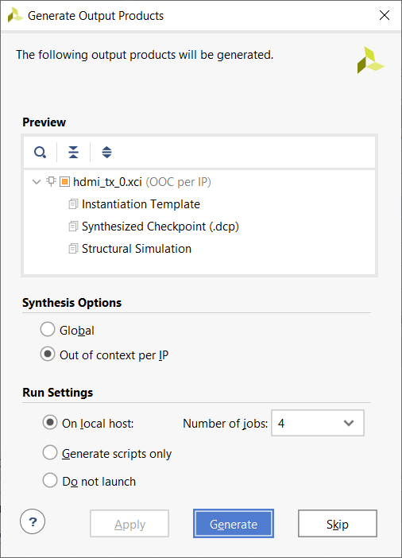

- Click OK in the Generate Ouput Products pop-up.

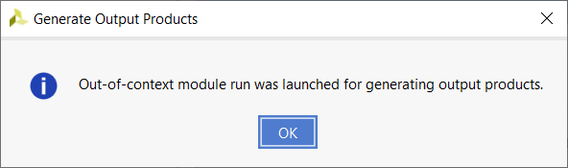

- You should now have

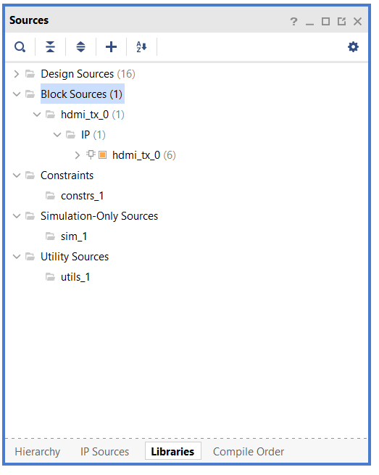

- You can see the details of the interface by opening hdmi_tx_0.v Yes, this is a Verilog file and the Vivado tool can compile together HDL files that are written in Verilog and VHDL.

